**Project Description:**

DentalLens is a web-based application designed to help users identify potential dental issues through image analysis. By uploading or capturing a photo of their mouth, users receive an AI-generated diagnosis detailing possible symptoms, severity, and causes of dental conditions. The system also offers personalized video recommendations, a chatbot for dental-related questions, and a calendar to track dental appointments making oral health monitoring accessible, interactive, and easy to manage for everyone.

**Requirements Summary:**

|  |  |  |
| --- | --- | --- |
|  | **MINIMUM REQUIREMENTS** | **RECOMMENDED REQUIREMENTS** |
| **OPERATING SYSTEM** | Windows 10 / macOS Mojave (10.14) or higher | Windows 11 / macOS Ventura (13) or higher |
| **PROCESSOR** | Dual-Core (Intel i3 / AMD equivalent) | Quad-Core (Intel i5 / AMD Ryzen 5 or better) |
| **RAM** | 4 GB | 8 GB or more |
| **BROWSER** | Latest version of Chrome, Firefox, or Safari | Chrome or Edge (latest stable release) |
| **DISPLAY** | 1280 x 720 resolution | 1920 x 1080 resolution or higher |
| **INTERNET** | 5 Mbps connection (Wi-Fi or LAN) | 10+ Mbps for smoother experience |
| **OTHER REQUIREMENTS** | Webcam (for image capture) or photo upload | Webcam + local file storage for uploads |

Table 1. System Requirements

DentalLens is built to run smoothly on most modern desktop and laptop systems. It requires only a standard browser and internet connection to function, making it accessible even to users without high-end hardware.

The system supports image uploads or real-time camera-based scanning, which requires either a built-in or external webcam. With modest processing and memory requirements, the platform ensures efficient performance on commonly available hardware. Users with more powerful systems will experience faster image processing and smoother interactions across the site.

**Prototype Github Link:**

https://github.com/dlGuiri/https---github.com-dlGuiri-Dental_Lens.git

**User Scenario:**

Josh had been dealing with tooth discomfort for weeks. At first, he ignored it, thinking it would go away. But as the pain lingered, so did his worries. The nearest dentist was far, the cost of a check-up was high, and what if it turned out to be nothing? He didn’t want to waste time or money. The fear of an unnecessary visit kept him from making an appointment.

One evening, while scrolling on his phone, he discovered DentalLens, a free website that analyzes your teeth through a simple photo. Curious and a bit desperate, Mark took a quick selfie of his teeth and uploaded it. Within moments, he received a detailed analysis showing symptoms, possible causes, and even how severe the issue might be. The site also recommended whether he needed to see a dentist urgently or not.

Relieved by the guidance and impressed by how easy it was, Josh finally booked a dental appointment this time, with confidence and purpose.

**DentalLens Mock-up/Prototype:**

**Main Dashboard**

Upon accessing the website, the user is presented with the main dashboard, which serves as the central hub for all key features. This dashboard includes a detailed history of previous teeth scans, a summary of the current condition of their oral health, and clearly organized panels that provide quick access to other important pages of the site such as the chatbot, dental tips, and appointment tracking.

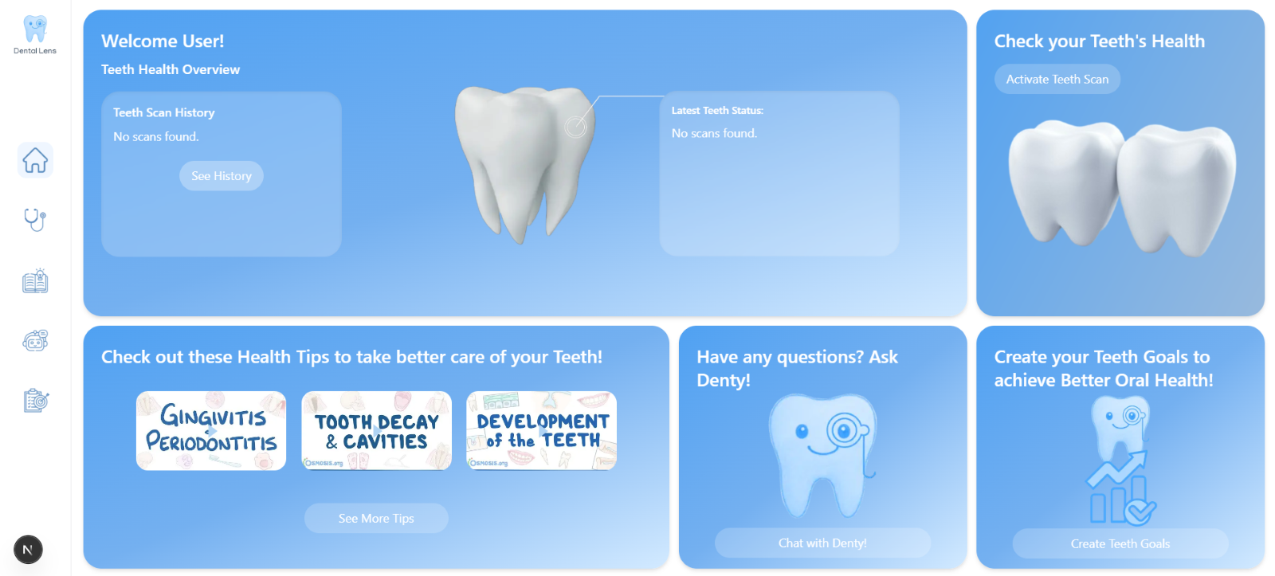

**Scanning Page**

The next section is the scanning page, where users have the option to either upload an existing photo of their mouth or take a real-time picture using their device’s camera. Once the image is submitted, the system processes it using deep learning models to analyze the user’s oral health condition. After the analysis, the system provides a detailed diagnosis, including the severity of the issue, possible symptoms, and the likely cause of the identified dental disease.

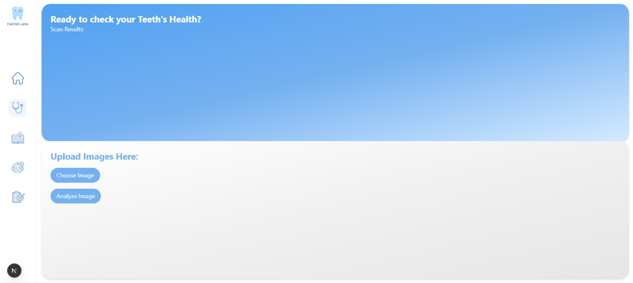

**Recommended Videos Page**

The next section is the recommended videos page, which dynamically updates based on the user's most recent teeth analysis. This feature ensures that the content is tailored to the user's specific oral health needs. The page presents a collection of informative videos, such as proper brushing techniques or tips for managing identified dental issues. Users can navigate through the available videos using the left and right arrows to browse, and their selected video will appear in the larger main video frame for easy viewing.

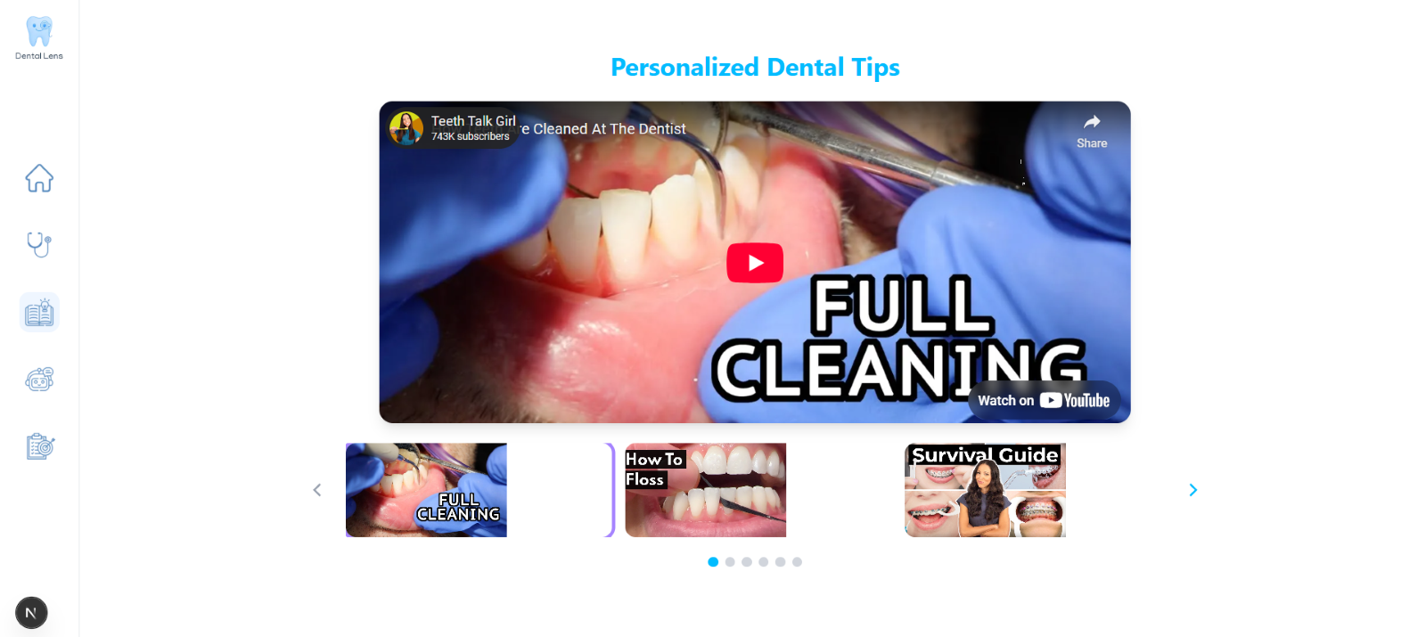

**Chatbot Page**

The next section is the chatbot page, where users can ask questions or seek clarification about anything related to oral health. This feature is powered by our AI assistant Denty, represented by a friendly tooth icon with a smiling face to create a more approachable and engaging experience. Denty is designed to provide helpful responses in real-time, guiding users with accurate dental information, tips, and support based on their concerns or curiosity.

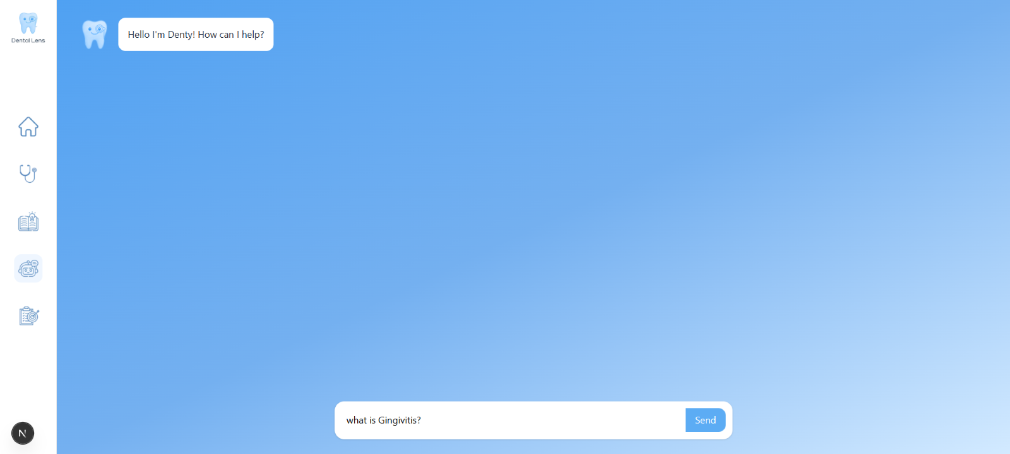

**Tracker Page**

Lastly, the tracker page allows users to manage their dental-related schedules with ease. This feature is represented by a user-friendly calendar interface where individuals can input important dates such as dental checkups, treatments, or personal reminders related to their oral health. Users have the ability to add, edit, or delete entries as needed, helping them stay organized and consistent with their dental care routines.

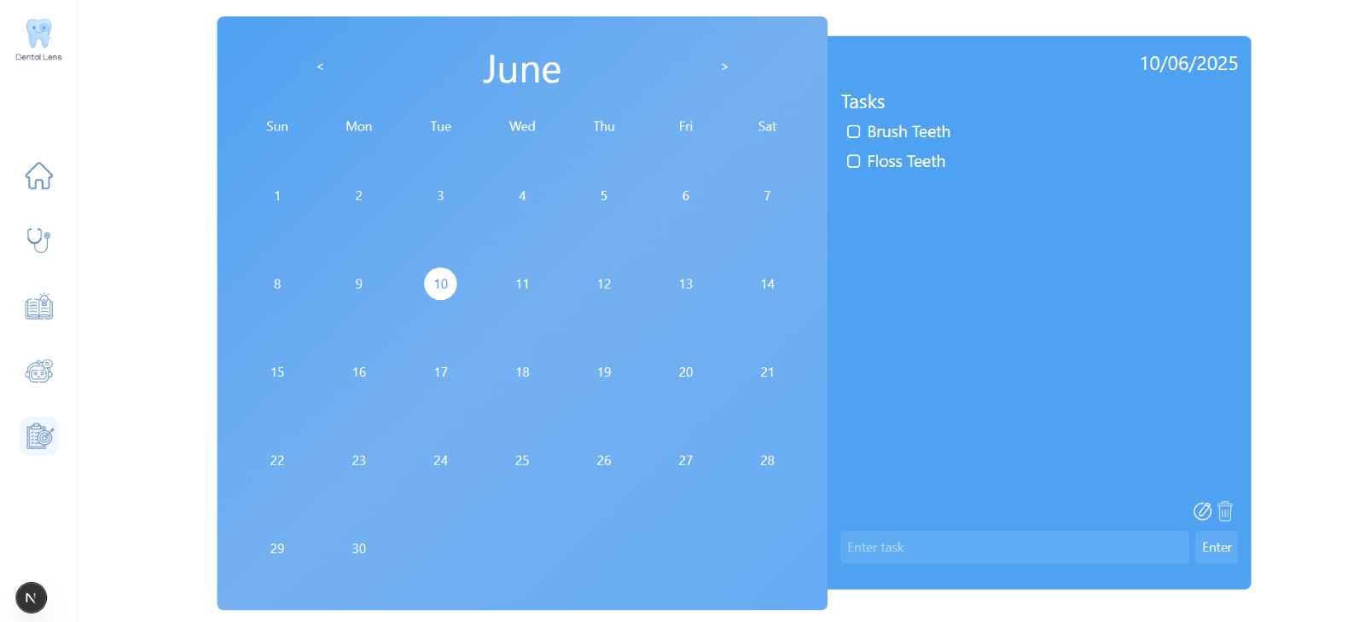

**Rationale:**

The team has chosen to develop the prototype using React with JavaScript due to its flexibility, responsiveness, and wide developer support. React is a powerful front-end library that allows for fast and efficient rendering of user interfaces. It enables the team to build a more realistic and functional prototype that closely mimics the expected behavior of the final product.

Using React also allowed for component-based development, making it easier for multiple team members to work on different features simultaneously. In addition, because React applications can be deployed online, it simplifies demonstration and testing, especially for users and stakeholders who are working remotely.

However, using React comes with its challenges. It requires a more technical setup compared to drag-and-drop prototyping tools, and debugging can take time, especially for team members who are still getting used to the development environment. Additionally, since the prototype runs in a browser, it depends on modern system resources to perform smoothly and may not work well on outdated hardware.

**Changes to Requirements:**

While the system requirements remained unchanged, the usability criteria of the prototype underwent significant revisions. These updates were guided by the central question: “How easy is it for a user to interact with this prototype?” The updated evaluation draws from key principles of the 10 Usability Heuristics, including minimalist design, recognition over recall, user freedom and control, flexibility, and interface consistency.

**Initial Evaluation Plan:**

The evaluation plan is divided into three key components, which are Usability Specifications, which define measurable usability goals, Heuristics Evaluation, where the prototype is assessed against established usability principles, and Participant Survey and Feedback, which gathers direct input from users to identify areas for improvement.

**Usability Specifications:**

The development of this prototype aims to meet the following usability measures to ensure a smooth and user-friendly experience:

**Effectiveness:** This measures how accurately and completely users are able to achieve their goals using the prototype. A successful design ensures that all core features—such as scanning teeth, accessing dental tips, and using the chatbot—perform reliably and as intended.

**Efficiency:** This evaluates how quickly and easily users can complete tasks with minimal steps and effort. The prototype is designed with a clean, intuitive layout to minimize confusion and reduce user interaction time.

**Utility:** This determines whether the prototype provides all necessary features and tools for the user to achieve their goals. It ensures the system supports relevant functions like uploading dental images, tracking appointments, and receiving recommendations.

**Learnability:** This measures how quickly new users can become proficient with the prototype. By using familiar UI elements and straightforward navigation, the prototype aims to minimize the learning curve for users of all ages.

**Satisfaction:** A system that feels pleasant and rewarding to use encourages users to return and trust the platform for managing their oral health needs.

**Heuristic Evaluation**

The evaluation of Dental Lens utilizes 10 Usability Heuristics to assess the overall user experience and ensure a user-friendly design:

1. **Visibility of System Status**  
    The system provides immediate feedback to users during scanning, analysis, and when navigating between pages.
2. **Match Between System and the Real World**  
   Dental Lens uses familiar, non-technical dental terms to align with what users understand and expect. The interface mirrors common health app layouts for familiarity.
3. **User Control and Freedom**  
    Users can easily cancel actions such as scans or uploads. Options like “Back,” “Clear,” and “Cancel” are clearly labeled and allow users to leave unwanted states without confusion.
4. **Consistency and Standards**  
    The prototype maintains a consistent design language throughout icons, button styles, and layout elements that behave predictably across all pages.
5. **Error Prevention**  
    Users are prompted before submitting incomplete forms or uploading unsupported files. Preventative checks are built in to minimize mistakes.
6. **Recognition Rather Than Recall**  
    Navigation elements are always visible. Instructions and tooltips are also available on-screen to guide first-time users.
7. **Flexibility and Efficiency of Use**  
    New users are guided through key features intuitively, while returning users can quickly navigate to recent scan history or saved appointments with a few clicks.
8. **Aesthetic and Minimalist Design**  
    The interface is intentionally clean and minimalist. Only relevant information like scan results, appointment reminders, and actionable tips is shown to avoid cognitive overload.
9. **Help Users Recognize, Diagnose, and Recover from Errors**  
    If errors occur, the system clearly describes the issue and offers suggestions such as retaking the photo or checking lighting.
10. **Help and Documentation**  
     Users can easily access a dedicated Help section or consult the chatbot "Denty" for guidance on using the system or understanding their scan results.

**Population:**

Around 10 randomly selected college students will be asked to use the prototype. They will be required to complete specific tasks designed for the prototype, such as uploading an image or accessing dental recommendations. The DentalLens prototype must successfully perform these tasks in order to be considered effective and complete.

**Prototype Tasks**  
The tasks for this prototype are divided into three (3) main sections: **Navigation Tasks**, **Scanning and Analysis Tasks**, and **Scheduling Tasks**. Below are some of the tasks that the selected participants will be asked to perform to demonstrate the functionality and usability of the DentalLens prototype:

* Enter and exit the prototype (Navigation Task)
* Navigate through different pages such as Scan, Chatbot, Tracker, and Recommendations (Navigation Task)
* Upload or capture a mouth image using the Scan feature and view the results (Scanning and Analysis Task)
* Review dental analysis including severity, symptoms, and causes (Scanning and Analysis Task)
* Interact with the chatbot for dental-related inquiries (Navigation Task)
* Add, edit, and delete schedule entries in the dental calendar (Scheduling Task)
* Play, pause, and switch between recommended videos (Navigation Task)

These tasks aim to evaluate how intuitive and functional the interface is during real user interaction.

**Roles:**

|  |  |
| --- | --- |
| **Developer / UI Designer Member** | **Task(s)** |
| Darwin Guirigay | Will record the time users spend interacting with each task section, observe and take notes on user behavior and difficulties, and guide participants through the assigned tasks. |
| Josef Lechoncito | Will also monitor user interaction time, document feedback and usability issues, and assist in instructing users on what tasks to perform during the evaluation. |
| Gavin Rivera | Will be responsible for tracking task completion times, noting participant reactions and comments, and ensuring that users understand and complete each step in the evaluation. |

All members will collaborate in reviewing the feedback, analyzing results, and identifying necessary improvements for the prototype based on user experiences.

|  |  |  |  |
| --- | --- | --- | --- |
| Dashboard Navigation | Within 1 minute or below | Highly Acceptable | Successful |
| Above 1 minute | |  | | --- | |  |  |  | | --- | | Not Acceptable | | |  | | --- | |  |  |  | | --- | | Unsuccessful | |
| Teeth Scanning & Upload | Within 5 minutes or below | Highly Acceptable | Successful |
| Above 5 minutes | |  | | --- | |  |  |  | | --- | | Not Acceptable | | |  | | --- | |  |  |  | | --- | | Unsuccessful | |
| Viewing Analysis & Recommendations | Within 5 minutes or below | Highly Acceptable | Successful |
| Above 5 minutes | |  | | --- | |  |  |  | | --- | | Not Acceptable | | |  | | --- | |  |  |  | | --- | | Unsuccessful | |

This time-based criterion evaluates how user-friendly and efficient the Dental Lens system is in completing its key tasks: navigating the dashboard, uploading/scanning mouth images, and reviewing dental health results

**Participant Survey and Feedback**

|  |  |
| --- | --- |
| DATA GATHERING METHOD | DESCRIPTION |
| Survey (Quantitative) | After face-to-face testing, the team will be handing out a survey to the participants to gather data regarding the users’ experience with the prototype. The feedback collected will be interpreted using a 5-point Likert scale |
| Feedback (Qualitative) | The survey distributed by the team will include a feedback section that allows users or participants to express any concerns or issues they encountered while using the prototype, helping identify areas that may need improvement. |

|  |  |
| --- | --- |
| **QUESTION** | **METHOD OF ANSWER** |
| Section 1: General Functionality | |
| The system operates as intended without major bugs. | 5-point Scale |
| Features are fully functional and accessible. |
| The system behaves consistently without crashing. |
| The errors messages or prompts are helpful and understandable. |
| Section 2: Usability and User Experience | |
| The interface is intuitive and user-friendly | 5-point Scale |
| Navigation is clear and straightforward |
| The visual design is appealing and consistent |
| Instructions and help resources are sufficient |
| The system is accessible for users with different needs and skills |
| Section 3: Feedback Section | |
| Open Feedback | Short Answer |

This evaluation form is divided into three sections to assess the overall performance, usability, and user satisfaction of the prototype. Sections 1 and 2 use a 5-point Likert scale to measure how well the system functions and how easy it is to use. Section 3 provides an open feedback area where participants can share comments, suggestions, or issues they encountered while using the system.

|  |  |  |  |
| --- | --- | --- | --- |
| **Scale** | **Range Value** | **Interpretation** | **Classification** |
| 5 | 4.50-5.00 | Highly Acceptable | Successful |
| 4 | 3.50-4.49 | Acceptable |
| 3 | 2.50-3.49 | Moderately Acceptable | Neutral |
| 2 | 1.50-2.49 | Fairly Acceptable | Unsuccessful |
| 1 | 1.00-1.49 | Not Acceptable |

This table presents the interpretation guide for the 5-point Likert scale used in evaluating the prototype. Each numeric value corresponds to a qualitative interpretation and classification, helping the team assess whether specific aspects of the system are successful, neutral, or require improvement based on user feedback.